Smart Campus System
Sagar Vasekar, Roshan Pawar, Digvijay Pisal
Sinhgad Institute of Technology, Lonavala
Computer Engineering, Pune University
Email :sagarvasekar007@gmail, getconnectedtoroshan@gmail, dgvjy_pisal@yahoo.co.in

Abstract— This work-in progress paper summarises our project towards the vision for creating a web portal cum service for Smart Campus .Smart Campus System will be new trend with proposed of iCampus. The framework of the smarter campus is discussed and the architecture is expressed in detail, based web architecture and the characteristics of the intelligence. To capture part of the essence of the concept, some of the key challenges pertinent to the Smart Campus System have also been highlighted within the campus value proposition framework.

Keywords— Intelligent Campus, Step towards smart campus,
Smarter Campus System, smart environment,
Framework for smart campus
- Introduction
With the development of society, education is paid more attention to. There are certain difficulties in the management of campus. The management of Campus is getting difficult after merging of school and different colleges and the management and services of large scale students after expansion have become more important event in the management and construction of Campus environment. The proposal of the concept smarter planet is exciting news and for intelligent development environment going to be new trend, and development of smarter campus should also comply with the time. The application of new technologies like cloud computing, RFID, IPv6 , do well to the development of smart campus environment. It is the new direction for future informationization that the creation of smarter campus for teaching , management, and service at higher platform. In a campus environment substantial number of users share a large amount of their information needs. These needs include information like schedules, locations of class rooms, lectures, assignments, lab equipments, presentations, seminars, sports events, student ads, and lot more. Much of these information is related to the objects, places, and peoples that are situated within campus environment. So, it is better idea to make this information to be available at one place. So, design of web based information availability is a really good idea for this. And it will be useful for those who are situated within campus as well as for those who are not. As there is no need of any hardware part for this implementations the previous smart campus systems.
The remainder of this paper is organised as follows. In the next section the difference between already existing systems and proposed smart campus system is given. In section 3, the framework model of smart campus is proposed. The smart campus road map feature is explained in section 4. And the detail construction process is discussed in section 5.Finally some conclusions and some research directions are expressed in section 6.
- The Difference between already existing systems and proposed Smart Campus System

Smart campus is the trend in the development of future intelligence. New technologies and theories are introduced to support this idea, such as smart planet, digital campus, cloud computing, virtualization and so on. The structural diagram for theoretical foundation and technical support for smart campus is expressed in details in later part.
- Already existing smart campus environments
There are already existing many smart campus environments implemented previously. That were implemented using technologies like:
- Radio Frequency Identification (RFID)
- ZigBee
- Virtualization and many more.
There was requirement of some hardware parts like for Security or other purposes. On the other hand the cost of installing and maintaining those hardware parts was also expensive.The system failure was dependant on the failure of single device.There was need high initial investment and man power also.
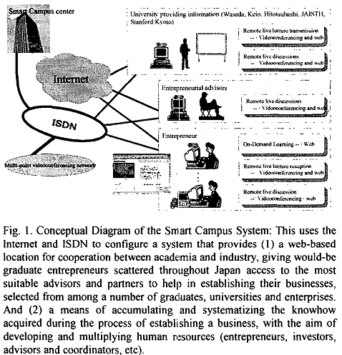
The above figure shows how the previously designed iCampus system is.
The diagrammatic overview of iCampus system can be shown as follows :
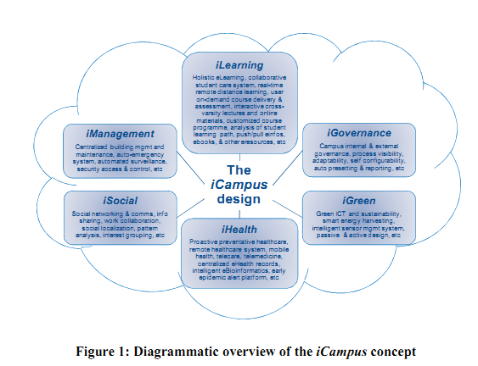

- Our Smart Campus System
We are going to build one web portal for campus which will be useful for all peoples even who want to enroll for admission as well as for visitors and students. The web-site will provide all the information about the campus. So, person sitting in the home can also get all the details about the campus. He will be able to view all the information about the campus like social, political history of campus. The person can also take advantage of the path finder application included in the web-site. Also the person can use the SMS facility provided by the web-site. In proposed system their is no need of any hardware part. So, comparably it is less costly than others. It is as well deployed on the cloud also. The terminal goal of the cloud computing is to provide computing to the users as public accommodation. Cloud computing is a service based on Internet. Browser is the only software needed, and users can use resources on demand, pay on demand to save unwanted payment. Data is saved in the cloud, people can use at any time with the help of internet. All the facilities and services will also be deployed on the cloud.
- Framework model for Smart Campus System
- Smarter Campus and Digital Campus
Intelligence is the unavoidable result of digitization and digitization is the essential process of intelligence. Intelligence is the global and sustainable development. Yhe harmonious is based on the digitization, and under the condition of internet, which also includes factor of person. It is harmonious between people, environment and general.
Digital campus has been proposed for almost 20 years, and most of the campus has constructed the infrastructure. All these may be well preparations for smarter campus. Smart campus is a will. In this system all resources can be used on demand.
- Characteristic of Smart Campus System
There are some characteristics of smart campus system that are different from others. Also there is no need of any hardware devices. It also give the service of path finding. As it is not at all expensive it is more helpful and efficient to use.

- Framework model for Smart Campus
Basically it is different from all other previously implemented smart campus environments. It is based on web system. As it will be available to the user 24x7 to the user. User can also get answers to their questions by asking quaries.It includes variety of functionalities like Paid SMS alert facility, downloading reports in pdf file format, live map of campus with key places in it, other social, political history of the campus.
IV. Smart Campus Road Map
The proposed Smart Campus System also provides road map of the campus for giving ease in finding the key places in the campus. The road map of Smart Campus can be used by the peoples who are new to the campus. It is always essential for any big campus to have a roadmap of the campus so the peoples who are new to the campus can get it right.
V. Construction of Smart Campus System
As explained above , construction process of smarter campus is based on web architecture can be concluded as follows :

Step 1 : Requirement Gathering
The first step will be gather all the requirements about the campus. This information may be like collecting number of colleges and gather all the information about the respective college. So, for that purpose only their are sub-admins included in the system who will work at college level and provide all the information to the admin So, such all kind of information of the campus will be gathered in first phase.

Step 2 : Modeling
The second phase will be of modelling all the information available in some kind of model. In this phase business case of the entire system will be prepared.

Step 3 : Construction
In this phase all the construction work will be done. The website will be build in this phase. Also testing on that web site will be done . In the path finding application of the web-site the SMS facility will be used. Like their will be a user at campus main gate and want to go to Pharmacy college then will first get himself verified on the site. After successful verification he will send a message that he wants to go from main gate to the Pharmacy college and he will be able get then the entire path details from the path of main gate to pharmacy college.

Step 4: Deployment
After all implementation has been completed the entire web-site will be deployed on the cloud . And side by side testing of web site will also performed.
VI. Conclusions
This paper fully summarizes all the necessary things about the Smart Campus System, Difference between the existing and this Smart system. So, it can be concluded that as their is no need of any hardware part for implementation it is less expensive. It provides 24x7 availability. It will be useful for all the parents and students. And also does the work of path finding but in different and efficient way. It also provides SMS alerts. It is more convenient and flexible than previous system. It do the work of same previously implemented system but without any use of hardware devices.
Acknowledgment
We would like to thanks to Sushil Kukreja and Puneet Sharma sir for helping us a lot in doing this work.
We would also like to thank Jai Chavan mam from SIT who is always there with for our help. And also thanks to Phule sir and Anuradha mam.
And thanks to those who always helped us directly and indirectly .
References
- A discussion on the framework for Smart Campus. Liu Chuling, Xie Zanfu, Peng Ping
- A step towards the Smarter Campus. Atsushi Kaneko, Noboru Sugino, Toru Suzuki, Shintaro Ishijima.
- The iCampus project under MIT-Microsoft Alliance: http://icampus.mit.edu
- M.T. Khan and K. Zia, "Future Context-aware Pervasive Learning
Environment: Smart Campus", Int. Conf. Integration of IT in Sci. Edu., 2007.
- P. Doulai, "Smart and Flexible Campus: Technology Enabled University Education", Proc. of World Internet & Electronic Cities Conf., 94-101, 2001.
- M. . Jackson, "Intelligent Campus", Int. Sym. Perv. Comp. & Apps., 3-9, 2006.
- Y. .B. Chen, C.J. Yang, and G.J. Jong, "Intelligent Campus Multi-application RFID Integration System", Int. Conf. on Intelligent Information Hiding & Multimedia Signal Processing, 504-507, 2008.
- M. . Davies, V. Callaghan, and M. Gardner, "Towards a Mixed Reality
Intelligent Campus", IET 4th Int. Conf. on Intelligent Environments, 1-6, 2008.
- L. S. Machado, T.K.L. Costa and R.M. Moraes, "A 3D Intelligent Campus to Support Distance Learning", Int. Conf. IT Based Higher Edu. & Train., 2006.
- M. Fickes, "The Smart Campus", College Planning & Management, 2004.
- Q. Jones, "NJIT’s SmartCampus Project to Create Closer Connections", New Jersey Institute of Tech., 2006, http://smartcampus.njit.edu/publications.html .
- E. Saby, "Schlumberger Smart Campus Access Technology Provides the University of Texas at El Paso with Virtual Campus Solution", Axalto,2000.
- [13] CSaby, "Schlumberger Smart Campus Access Technology Provides the University of Texas at El Paso with Virtual Campus Solution", Axalto, 2000.

